ИИпир Ци“Київський фаховий коледж зв’язку”

Циклова комісія Комп’ютерної та програмної інженерії

**ЗВІТ ПО ВИКОНАННЮ**

# **WORK-CASE №2**

з дисципліни: «Операційні системи»

**Тема: «Робота з гіпервізором Virtual Box»**

Виконали студенти

групи КСМ-13а

Команда BBC:

Петрик С.С,

Панчук О.С.

Перевірив викладач

Сушанова В.С.

Київ 2022

Завдання №1  
виконав: Петрик С.

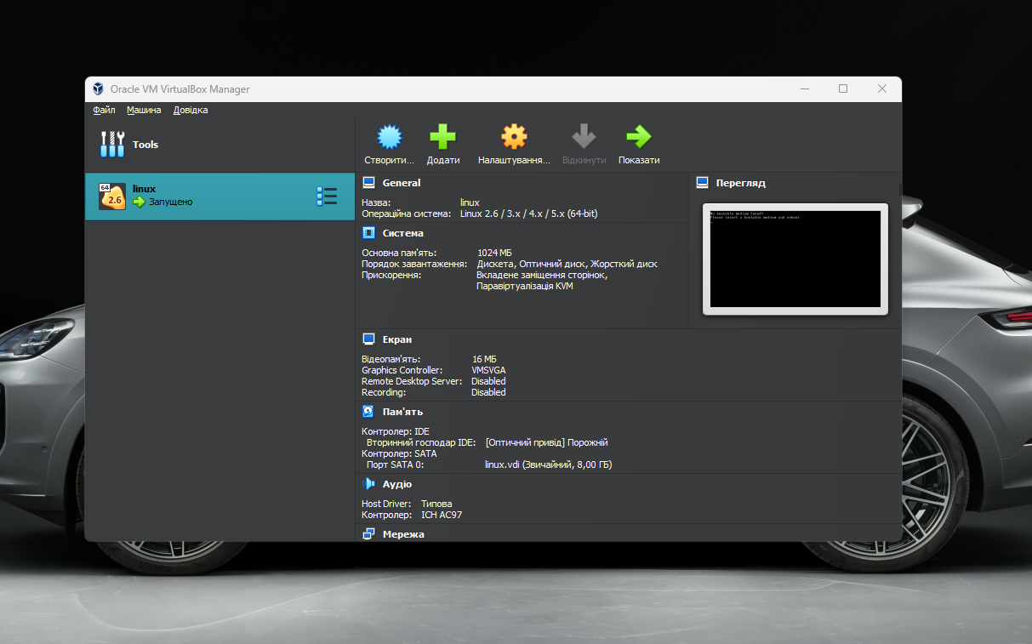

Завдання №2

виконав: Петрик С.

. Creating a New Virtual Machine:

To create a new virtual machine, you would typically open the hypervisor's management console.

Click on the "Create New Virtual Machine" or similar option.

Follow the setup wizard, which includes specifying the VM's name, location, and OS type.

You may also allocate resources such as CPU cores, RAM, and storage space during this process.

* Selecting/Adding Virtual Hardware:

After creating a virtual machine, you can configure its virtual hardware.

This usually involves accessing the VM settings.

You can add virtual CPUs, allocate more RAM, attach virtual hard disks, and specify boot order.

Some hypervisors also allow you to add specialized hardware like GPUs, USB controllers, or serial ports.

* Configuring Networking and Connecting to Wi-Fi:

To configure networking for a virtual machine, you typically access its network settings.

You can choose from various networking modes (bridged, NAT, host-only, etc.).

If you want to connect to Wi-Fi, you might need to set up the virtual machine's network adapter to bridge with the host's Wi-Fi adapter or use NAT with port forwarding.

You may need to provide Wi-Fi credentials within the virtual machine's operating system.

* Working with External Storage (Flash Memory):

To work with external storage devices like flash drives, you would first ensure that the hypervisor supports USB passthrough or device sharing.

Connect the flash drive to your host computer.

In the hypervisor's management interface, select the virtual machine you want to use the flash drive with.

Find the USB or external device settings for that VM and select the connected flash drive.

The virtual machine should now recognize the flash drive, and you can access it from within the VM as if it were physically connected.

Завдання №3

виконав: Петрик С.

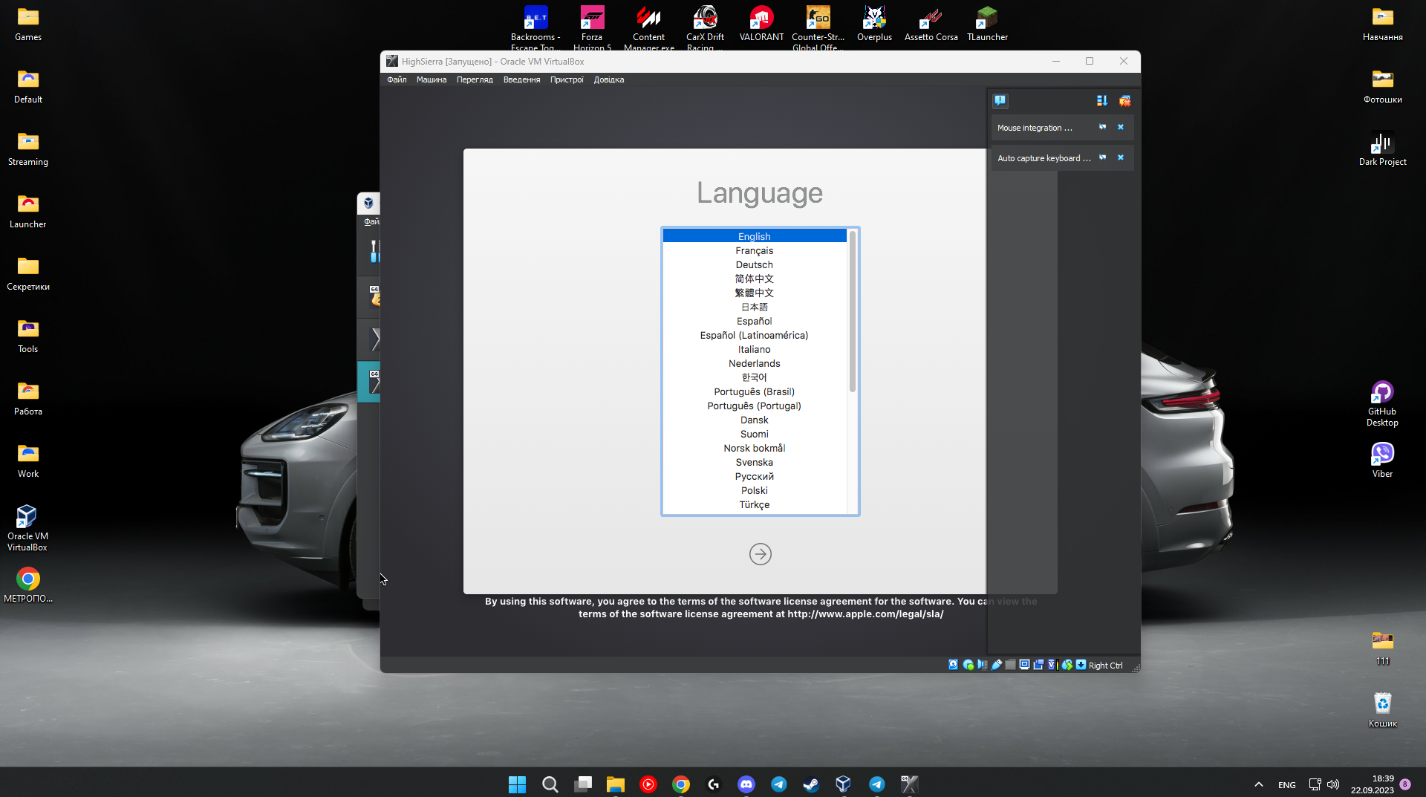

Завдання №4

виконав: Панчук О.

1.Install a minimal configuration of the Linux CentOS operating system with terminal input-output and without a graphical interface.

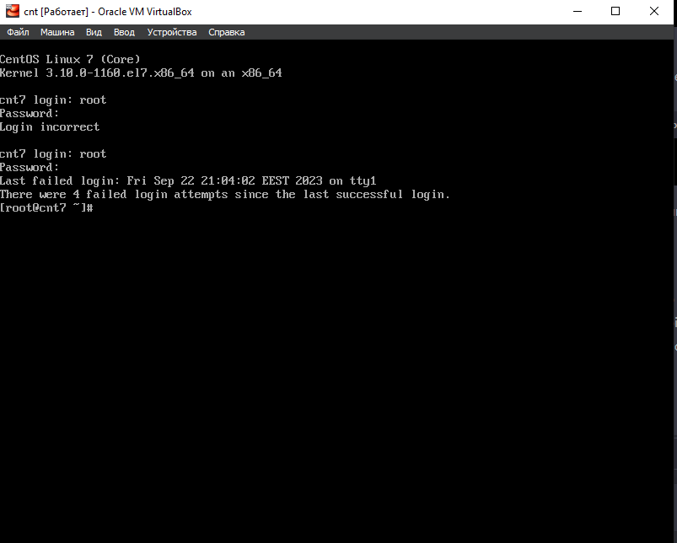

2.Команда yum upgrade

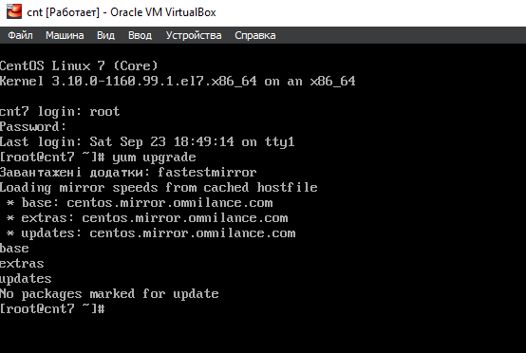

Команда apt-get upgrade

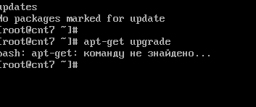

Команда yum -y groupinstall "KDE desktop" "X Window System" "Fonts"

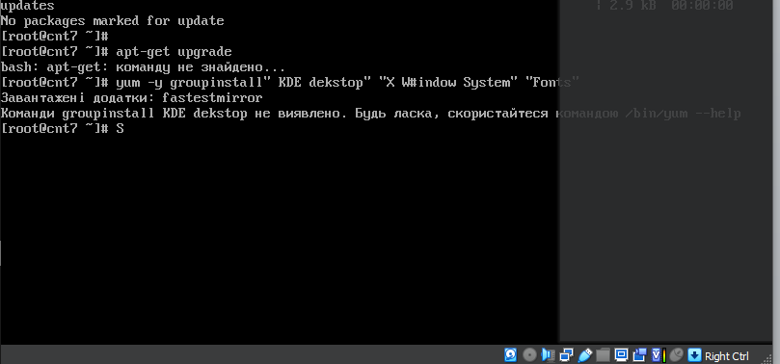

apt-get install ubuntu-gnome-desktop

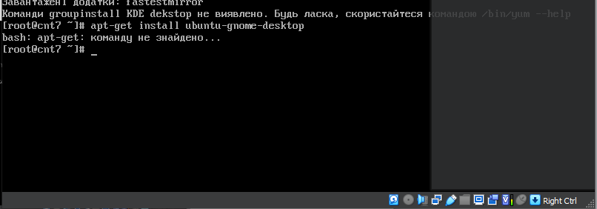

Майже всі команди які пробував не знаходить,або пише що вони заблоковані. Я пробував багато команд але зазвичай просто пише “Пакунок заблокований”

Навіть ті команди які ви скидали теж не допомогли